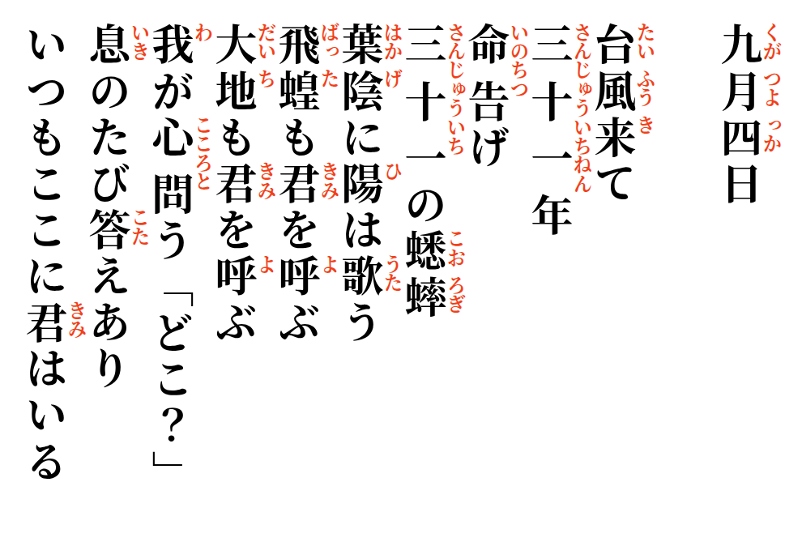
2026-09-08 Mitsue


A typhoon came—
thirty-one years ago,
announcing life.
Thirty-one crickets still sing;
the sun hums through the leaves.

Grasshoppers call your name.
The earth calls your name.
My heart asks, Where?
The answer rises with each breath:
you are here, as always.

